Science 10 – Physics Intro Name: ________________ Period: ____
Conversions and Scientific Notation
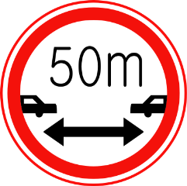
PART 1 – Distance: how far an object has traveled
- How many centimeters are in a meter? ______________ cm = 1 m
- How many meters are in a kilometer? ______________ m = 1 km
- How many millimeters are in a centimeter? ____________mm = 1 cm
- How many millimeters are in a meter? ______________mm = 1 m
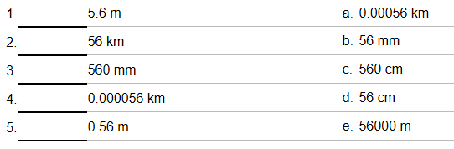
- Match the letter of the correct converted value to the following:

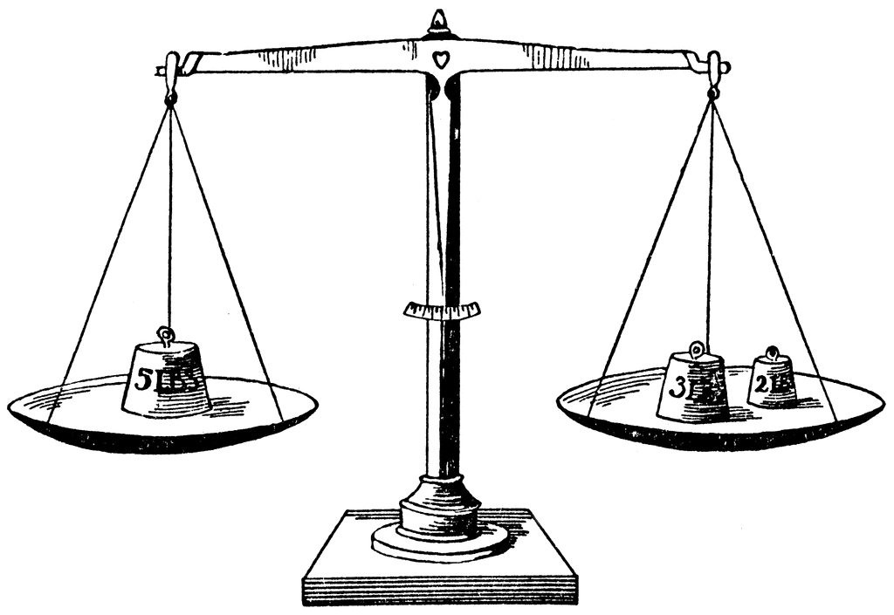
PART 2 – Mass: how heavy an object is
- How many grams are in a kilogram? ________________ g = 1 kg
- How many milligrams are in a gram? _______________mg = 1 g
- How many centigrams are in a gram? _____________ cg = 1 g
- Match the letter of the correct converted value to the following:
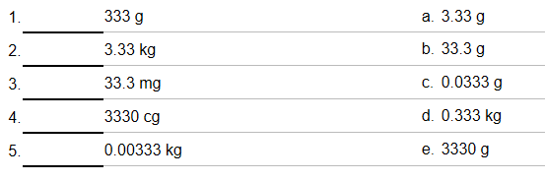

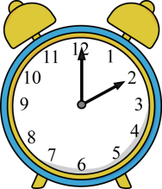
PART 3 – Time: how long it takes
- How many seconds are in a minute? ___________ s = 1 min
- How many minutes are in an hour? ___________ min = 1 h
- How many seconds are in an hour? ___________ s = 1 h
- How many hours are in a day? ____________h = 1 day
- Write the correct conversion for the following:

  - 45 min = ____________ s
  - 240 s = _____________ min
  - 240 s = _____________ h

  - 5 h = ______________ min
  - 7.8 hours = ______________ s
  - 0.054 hours = ____________ min

PART 4 – Speed: how fast an object is travelling
Sometimes conversions need to be two parts. For example, speed is measured in meters per second (m/s) or kilometers per hour (km/h). This is because speed is a rate. It represents how much distance is covered in a certain amount of time.
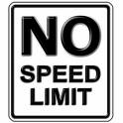
Here’s the easy way to convert speed: (just need to remember this…)
km/h to m/s mulitply by 1000 and divide by 3600
m/s to km/h multiply by 3600 and divide by 1000

This way is a bit tricky at first, but will really help you in future Science classes (chem/physics):
Example: 412 m/s = ______________km/h (to do this, multiply by “conversion factors”)

Try these:

- 50 km/h = _________________ m/s
- 805 km/h = ________________ m/s
- 1 m/s = __________________ km/h
- 8 m/s = __________________ km/h

PART 5 – Scientific Notation
Scientific Notation is used to represent very large or very small numbers.
- For example, instead of writing 52000, we can convert to scientific notation: 5.2 x 10⁴

- For example, instead of writing 0.00063, we can convert to scientific notation: 6.3 x 10⁻⁴

Rules: there can only be one digit before decimal point
the exponent indicates movement of decimal place:
Positive exponent 5.21 × 10 ⁴ = 52 100 (moves to the right)
Negative exponent 5.21 x 10⁻⁴ = 0.000521 (moves to the left)

Write the following numbers correctly in scientific notation:
1) 45000 - ______________ 2) 3450 - ______________ 3) 0.00000314 - _______________

4) 530000 - _____________ 5) 0.0052 - ______________ 6) 0.00068 - __________________

