Float Your Boat! – Scientific Method Project
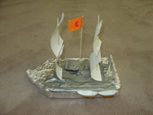
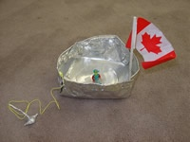

PROBLEM: Which boat do you think will hold the most pennies without sinking?
CHALLENGE: Can your group of 3 or 4 people design the best boat?
MATERIALS:
- 1 piece of tinfoil • 2 toothpicks
- 4 marshmallows • 1 piece of tape
- 2 felts • Candy wrappers
PROCEDURE:
- Find your group (they all have something in common that contained a tasty treat)

- Brainstorm (5 mins) in your group some ideas as to what will make your boat hold the most pennies and still float…design, shape, size, colour? What matters?

- Draw a rough sketch of your boat (5 mins) – be prepared to explain to the class why your boat will win the challenge.

- Build your boat (20 mins) – it doesn’t have to match your drawing – you are still trying to win the contest so make any changes now!

- Bring your boat to the duck pond for testing!
Float Your Boat – Class Data

Copy the data table on the board in to the space provided below.

Team Name | # of Pennies

Testing Ponds

Pond 1–
Pond 2–
Pond 3–
Pond 4-

Homework – due tomorrow:

Create a graph of the data above. You can use which ever type of graph you think is best. This graph must be done on a separate sheet of paper. You can draw it by hand or use the computer. Please make sure it is clear and easy to read.

