Types of Energy
What is ENERGY?

There are two main branches of energy:
Kinetic Energy (KE):  _____________________________________  The energy is contained in the movement of the object or movement inside of the object  Example: | Potential Energy (PE):  _______________________________________  Energy that can be kept for use at a later time.  Example:

The Ten Types of Energy
Type | Definition | Examples or Sources | PE or KE
Mechanical
Chemical
Gravitational
Light
Electrical
Nuclear
Magnetic
Elastic
Thermal
Sound
Energy Transformations
An energy transformation is a ________________ from one type of energy to another type. Energy is constantly changing form from one type into another. This is happening all around us throughout the Universe!
Example of Changes
 | Description | Energy In | Energy Out
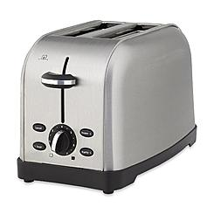 | Toaster
 | Guitar String being plucked
 | Toboggan going downhill
 | Smartphone/Tablet
Energy Transformations Practice: You Try!
 |  | Description | Energy In | Energy Out
1 |  | Gas Powered Grill
2 |  | Microphone
3 |  | Sail Boat
4 |  | Solar Panel Powered Communications Satellite
Think up your own example and discuss with a classmate!

