MECHANICAL ENERGY

DEFINITION: the energy of a moving object

CHEMICAL ENERGY

CHEMICAL ENERGY

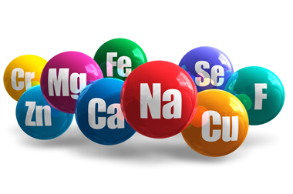
DEFINITION: the form of energy stored in matter

GRAVITATIONAL ENERGY

DEFINITION: The energy that an object has when it is above a surface

LIGHT ENERGY

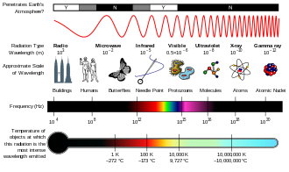
DEFINITION: Form of energy that you can see. The energy of the electromagnetic spectrum

ELECTRICAL ENERGY

DEFINITION: The energy of moving electrons.
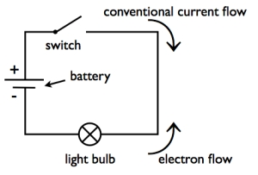

NUCLEAR ENERGY

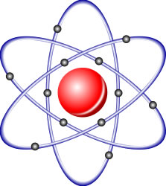
DEFINITION: energy stored in the atom

MAGNETIC ENERGY

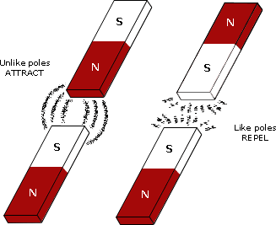
DEFINITION: energy that causes some types of metal to attract or repel

ELASTIC ENERGY

DEFINITION: energy stored in an object that can be stretched or compressed

THERMAL ENERGY

DEFINITION: the energy of moving particles inside an object
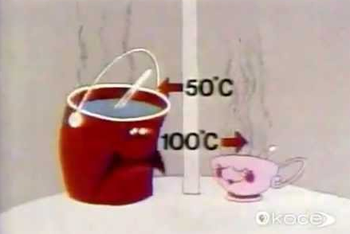

SOUND ENERGY

DEFINITION: energy you can hear

