THE PERIODIC TABLE: FAMILIES AND PERIODS
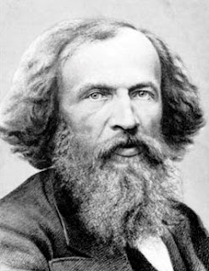
The periodic table was organized by DMETRI MENDELEEV
Mendeleev was a Russian chemist and inventor!
Organization
- Vertical columns are called FAMILES
  - Families share similar chemical and physical properties
- Horizontal rows are called PERIODS
  - Each period represents an orbit or shell around the nucleus
Using the INTERACTIVE PERIODIC TABLE, explore the families!
https://tinyurl.com/ptesci10
- ALKALI METALS
Write the description for Alkali Metals

Column | Name | Characteristics | Uses
Li
Na
K
Rb
Cs
Fr
*Reactivity increases as you go down the column!

- ALKALINE EARTH METALS
Write the description for Alkaline Earth Metals

Column | Name | Characteristics | Uses
Be
Mg
Ca
Sr
Ba
Ra

- TRANSITION METALS
Write the description for Transition Metals

CHOOSE YOUR TOP 3!
Column | Name | Characteristics | Uses

- METALLOIDS
Write the description for Transition Metals
CHOOSE YOUR TOP 3!
Column | Name | Characteristics | Uses
- NON-METALS
Write the description for Non-metals
Column | Name | Characteristics | Uses
C
N
O
P
S
Se

- HALOGENS
Write the description for Halogens

Column | Name | Characteristics | Uses
F
Cl
Br
I
At

*reactivity decreases as you go down the column, making fluorine the most reactive!
7. NOBLE GASES
Write the description for Noble Gases

Column | Name | Characteristics | Uses
He
Ne
Ar
Kr
Xe
Rn

- HYDROGEN
Write the description for Hydrogen

Column | Name | Characteristics | Uses
H

