Geologic Change Assignment
- The stream behind the school is gradually wearing away its bed.
  - Does it wear away exactly the same amount every day? Explain.

  - During which season of the year will the rate be the greatest? Explain.

  - Describe a method which you could use to measure the rate of wear.

- How long will it take to wear away 0.1 mm of rock if it is eroding at a rate of 0.0001 mm per year?

- How fast are the Coast Mountains rising if their average altitude has increase 1.5 m in 10 000 years?

- If the Atlantic Ocean is widening by 1.2 cm/year, how much wider has it become in your lifetime?

- Unit conversions: Convert each unit as requested. Some of these calculations require more than one step.
  - 15 km = ___________ m

  - 15 km = ___________ cm
  - 3.0 m = ____________ cm

  - 2.5 m = __________mm

  - 1.2 m/year = __________ cm/year

  - 2.5 m/100 years = ____________ cm/year

  - 28 cm/year = ______________ cm/day

  - 65 cm/3 years = ______________ mm/day

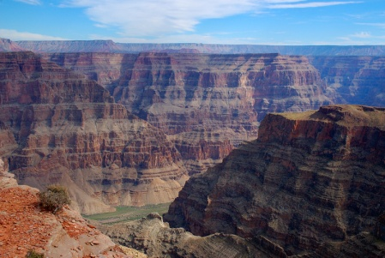
- The Grand Canyon in Arizona is 1.6 km deep. The rock at the bottom is 1500 million years old, while at the top it is 250 million years old.

  - How many years did it take to form these layers of rock?

  - What was the average rate of rock formation in mm/year?

  - Does the principle of uniformitarianism tell us that exactly this amount of rock was formed each year? Explain your answer.

