Data Table & Graphing Notes

What is a data table?

Example…
Boat lab data table:
Group | # of pennies
1
2
3
4
5
6

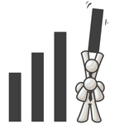

Terminology

Variable:

Independent variable:

Dependent variable:

Look at the “float your boat” data.

Which is the independent variable?

The dependent variable?

How do you know?

Why graph?

Types of graphs

Pie chart Bar graph/histogram Line graph/Scatterplot

Look at the pie charts that have been handed out with your group and develop a list of requirements that all pie charts should have in the space below.

Look at the bar graphs that have been handed out with your group and develop a list of requirements that all bar graphs should have in the space below.

Look at the line graphs that have been handed out with your group and develop a list of requirements that all line graphs should have in the space below.

Let’s try it…

Use the data below to create a scatterplot and then find the relationship between the variables by drawing a line of best fit.

Relationship of Braking Distance to the Speed of a Car

Speed (km/h) | Braking Distance  (m)
30 | 6.0
40 | 10.5
50 | 16.5
60 | 23.5
70 | 32.0
80 | 42.0

Create your graph here:

Interpolated Data: A value obtained from the graph that is between the data points plotted

Extrapolated Data: A value obtained from the graph that is outside the data points plotted

Practice:

A clam farmer has been keeping records concerning water temperature and the number of clams developing from fertilized eggs. He has been adjusting the water temperature in the clam tank and then checking on the developing clams. The results are shown in the data table below.
- What is the independent variable?

- What is the dependent variable?

- Plot the data in the space provided below. Make sure the variables are on the correct axis. Label the axes & make a title. Draw a curved line of best fit through the data.

Water Temperature in ºC | Number of developing clams
15 | 75
20 | 90
25 | 120
30 | 140
35 | 75
40 | 40
45 | 15
50 | 0

4. According to your graph, what is the optimal temperature for clam development?

PIE CHARTS

Music preferences in young adults age 14-19

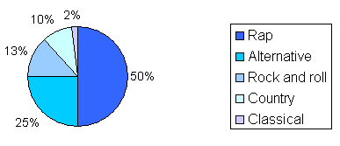

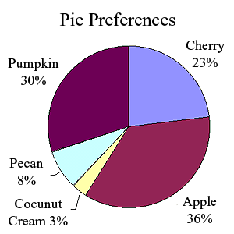

BAR GRAPHS

Internet use at Redwood SecondarySchool
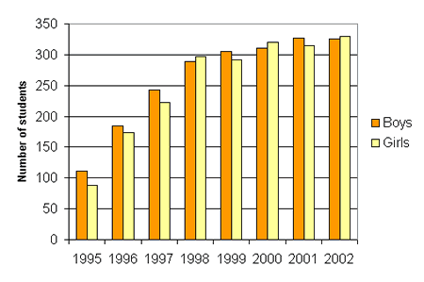

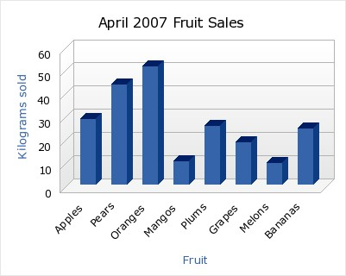

LINE GRAPH

