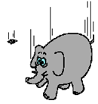Gravitational Potential Energy

**What is Gravity?**

When you are holding up an object, it has the POTENTIAL to fall. If you let go of that object it is attracted downwards towards the Earth (it falls!).

**How fast do objects fall?**

Observe the paper and the textbook demo. Record your observations on the rate at which each falls to the floor. (Which falls first?)

**Air resistance**: a ____________ force that opposes the motion of objects that move through air. On Earth, we have an atmosphere made up of air molecules, therefore there is air resistance. That’s why objects seem to fall at different rates.

Galileo suggested that if there was no air resistance, the weight of the object does not matter, and objects would fall at the ________ _______.(check out the David Scott video clip of the feather and the hammer on the moon!)

**The rate for any object falling on earth is ___________** (we will round it up to 10 in our calculations). In physics, we call this rate “**g**” which stands for **gravitational field strength**

[Image result for tennis ball vector](https://www.google.ca/url?sa=i&rct=j&q=&esrc=s&source=images&cd=&cad=rja&uact=8&ved=0ahUKEwiIlq3HxPvTAhVJz2MKHT_oBBcQjRwIBw&url=http://www.freepik.com/free-icon/tennis-ball_702736.htm&psig=AFQjCNHcchyYTICmEvHf0BORUA-V3BaJwg&ust=1495268815045721)

DROP

[Image result for tennis ball vector](https://www.google.ca/url?sa=i&rct=j&q=&esrc=s&source=images&cd=&cad=rja&uact=8&ved=0ahUKEwiIlq3HxPvTAhVJz2MKHT_oBBcQjRwIBw&url=http://www.freepik.com/free-icon/tennis-ball_702736.htm&psig=AFQjCNHcchyYTICmEvHf0BORUA-V3BaJwg&ust=1495268815045721)

after 1 second

[Image result for tennis ball vector](https://www.google.ca/url?sa=i&rct=j&q=&esrc=s&source=images&cd=&cad=rja&uact=8&ved=0ahUKEwiIlq3HxPvTAhVJz2MKHT_oBBcQjRwIBw&url=http://www.freepik.com/free-icon/tennis-ball_702736.htm&psig=AFQjCNHcchyYTICmEvHf0BORUA-V3BaJwg&ust=1495268815045721)

after 2 seconds

[Image result for tennis ball vector](https://www.google.ca/url?sa=i&rct=j&q=&esrc=s&source=images&cd=&cad=rja&uact=8&ved=0ahUKEwiIlq3HxPvTAhVJz2MKHT_oBBcQjRwIBw&url=http://www.freepik.com/free-icon/tennis-ball_702736.htm&psig=AFQjCNHcchyYTICmEvHf0BORUA-V3BaJwg&ust=1495268815045721)

after 3 seconds

* On the moon (which has a smaller mass than Earth, and therefore a weaker gravitational pull), the rate is ___________
* On the sun (if we could stand on it without burning up!) it’s _____________ (The sun is HUGE!)

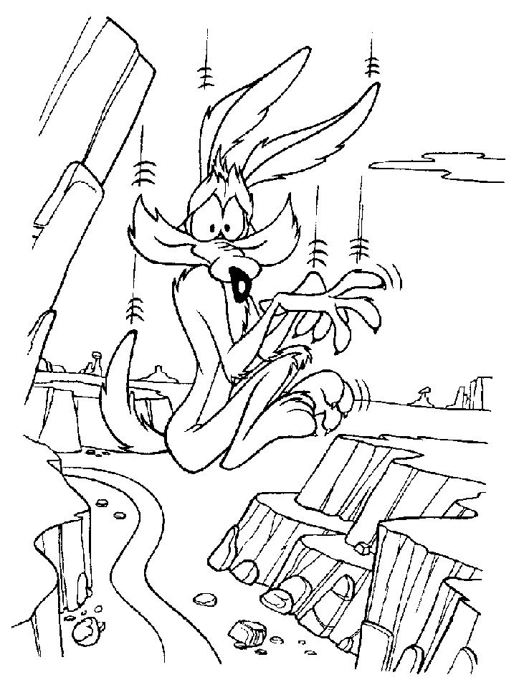**Gravitational Potential Energy**:

Brainstorm: What do you think gives an object more gravitational potential energy?

(ie. If something were to fall on your head, what factors would make it hurt more?)

# [Image result for object falling on head](https://www.google.ca/url?sa=i&rct=j&q=&esrc=s&source=images&cd=&cad=rja&uact=8&ved=0ahUKEwigwIX3u_vTAhUV52MKHfndBGcQjRwIBw&url=http://www.levitt-safety.com/blog/?month%3D11-2014&psig=AFQjCNGaNeH1GNVZlUrEAfwWya26UFlOcg&ust=1495266488781903)**Gravitational Potential Energy**



**Formula:**

**EP = mgh**

**Example Problems:**

1. A 15.0 kg object is lifted from the floor to a vertical height of 2.50 m. What is the gravitational potential energy of the object with respect to the floor?
2. A 50.0 kg student runs upstairs to the second floor of the school which is 4.32 m vertically above the ground floor, what is the gravitational potential energy of the student with respect to the floor?
3. A 10.0 kg object has 85 J gravitational potential energy with respect to the ground, how far off the ground is the object?
4. An object has 55 J of gravitational potential energy, and is located 2.0 m above the ground. What is the mass of the object?

Science 10 – Physics Name: ____________________ Period:_______

Gravitational Potential Energy Worksheet

1. [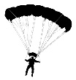](https://www.google.ca/url?sa=i&rct=j&q=&esrc=s&source=images&cd=&cad=rja&uact=8&ved=0ahUKEwjPvcT4vvvTAhUG2WMKHUj1AboQjRwIBw&url=https://clipartfest.com/categories/view/09f25ab63381f2588d58f7dd616f1fde2df04d79/skydiving-silhouette-clipart.html&psig=AFQjCNFGPTbgiVc8DBuDGG6DREh6fLQcjQ&ust=1495267303680363)Which of the following would have MORE gravitational potential energy? Explain why for each.
   1. Someone jumping out of a plane at 5000 m **OR** someone jumping out at 8000 m?

[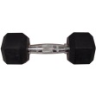](https://www.google.ca/url?sa=i&rct=j&q=&esrc=s&source=images&cd=&cad=rja&uact=8&ved=0ahUKEwiU7qSbv_vTAhVO7GMKHVOcC7sQjRwIBw&url=https://www.walmart.com/ip/Gold-s-Gym-Rubber-Hex-Dumbbell/21836977&psig=AFQjCNFXTdB9yy2YEe4Pv7QraAZ-HcYMbw&ust=1495267339101989)

* 1. a 5 pound dumbell held above your head **OR** a 25 pound dumbell held above your head?

[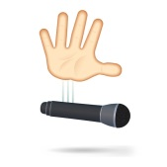](https://www.google.ca/url?sa=i&rct=j&q=&esrc=s&source=images&cd=&cad=rja&uact=8&ved=0ahUKEwiJlOmtv_vTAhVY7mMKHX8GBL4QjRwIBw&url=http://knowyourmeme.com/memes/mic-drop&psig=AFQjCNFK2LoqH6tFp-BKOM07EBKRk5sC2Q&ust=1495267418997038)

* 1. a. a mic dropped from 5 meters above the surface of Earth **OR** a mic dropped from 5 meters above the surface of Jupiter

1. A 2.50 kg object is held 2.10 m above the ground. What is the gravitational potential energy of the object with respect to the ground?
2. A 2.75 kg box is at the top of 7.0 m shelf. What is the potential energy with respect to the ground?
3. A 12.0 kg object has 105 J gravitational potential energy with respect to the ground, how far off the ground is the object?
4. An object has 65 J of gravitational potential energy, and is located 2.5 m above the ground. What is the mass of the object?
5. A 55.0 kg student runs upstairs to the second floor of the school which is 4.50 m vertically above the ground floor, what is the gravitational potential energy of the student with respect to the floor?
6. If a 50.0 kg student wanted to gain 15000 J of gravitational potential energy, how high would they have to climb vertically up at mountain?
7. On the planet Mars the gravitational field strength is different than on Earth. On Mars a 75 kg astronaut climbs to the top of a 25 m hill gaining 6958 J of gravitational potential energy.

(a)What is the gravitational field strength on Mars?

(b) How much potential energy would the same astronaut have on top of a 25 m hill on Earth?

(c) Would it be easier to climb up 25 m on Earth or Mars? Explain.

1. A 2.00 kg textbook is lifted from the floor to a shelf 2.10m above the floor.



(a) What is its gravitational potential energy relative to the floor?

(b) What is its gravitational potential energy relative to the top of the head of a 1.70m tall person?