**Precipitation Notes**

**Hydrologic Cycle (pg.499)**

Gas

Liquid

Solid

**Relative Humidity** - Amount of _________ _________ in the air ___________________ to the amount it could hold.

*Imagine this beaker can carry a maximum of 8 water molecules. If there are only 4 water molecules in the beaker, what is the relative humidity in the beaker? = spot for a water molecule*



**Saturation** - _________% Relative Humidity. Air is holding the ________________ water vapor capacity.

* + When it is ____________, the air can carry ______________ water vapor. (High R.H.)
  + When it’s cool, the air carries _____________. (Low R.H.)

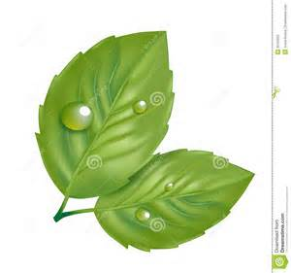**PRECIPITATION STATIONS**

**STATION #1 - FROST and DEW**

1. **Dew Point** – The temperature at which __________________________

(Also known as ___________% Relative Humidity)

1. **Frost and Dew Formation** – Both occur as air reaches _______ _________ while in contact with a _______________ ________________.
   1. If dew point is greater than 0 🡪 __________
   2. If dew point is less than 0 🡪 __________
2. Why do you think is there usually only dew/frost in the early morning?

Filename: j0432591.png
Keywords: clipped images, clouds, cloudy ...
File Size: 15 KB

**STATION #2 – Cloud Formation**

**Clouds** are basicallyhigh fogs or mist

1. Clouds Occur when _________________________________________
2. **CONDENSATION NUCLEI**: ___________________________________

For Example: _______, ________, or _________

1. If there are no condensation nuclei, then the air mass becomes __________________ (ie. Air has more water vapor than it should have!)
2. What are clouds made of?

🡪If temperature is greater than 0 degrees celsius🡪____________________

🡪 If temperature is less than 0 degrees celsius 🡪 _______________________

Filename: j0432588.png
Keywords: clipped images, clouds, cloudy ...
File Size: 16 KB**STATION #3 - Rain Drop Formation**

Step 1: small droplets form on _________________ _____________________

Step 2: These begin to ___________ through a cloud when they _____________

Step 3: Keep colliding and ______________ _____________________ until the droplet is __________ enough to fall

_________________

**At very high elevations…**

Step 1: Ice crystals exist and water ___________

Step 2: Water vapor ______________________ on ice crystals. These get _____________ and ______________ out of clouds.

1. How does the spraying of water on the glass represent how RAIN forms?

Filename: j0237936.wmf
Keywords: clouds, raindrops, raining ...
File Size: 43 KB**STATION #4 – Hail Formation**

Step 1:

Step 2:

Step 3:

Step 4:

*Cool Facts: Heaviest hail fell in 1970, it weighed in at 750 grams!*

*The largest hail fell in June of 2003 with a diameter of 7 inches or 17.8 centimeters!*

1. How does the hairdryer and ping pong ball challenge relate to hail formation?
2. Why is hail layered like an onion?

**STATION #5 – Why is the Sky BLUE?**

1. When the light is shining at a 90 degree angle, you see the colour: _________

2. As you move the light so that it is shining directly through the water, you see the colour: ___________

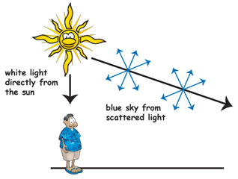3. From Earth, the sun appears yellow and the sky around appears blue. Explain in your own words why the sky is blue during the day, based on your observations and your understanding of the atmosphere.

4. If you look at the sun from outer space, the sun appears white and everything around appears black. Explain why.

**STATION #6 – Why are sunsets so colourful?**

1. Explain in your own words why you see the colours of the sunset/sunrise (red sky)?

