Exploring the Universe
What else is out there?

Galaxies
- A huge collection of gas, dust, and hundreds of millions of stars.
- The stars are attracted to each other by gravity, and are in constant motion.
- Our galaxy is the Milky Way, a disc shaped galaxy with our sun located in the outer portion of the disc. There are about 100 billion stars in the Milky Way.
- The centre is called the nucleus.
- TYPES OF GALAXIES:
  - Spiral Galaxies (ex. Whirlpool Galaxy, Milky Way)
  - Elliptical Galaxies
  - Irregular Galaxies (ex. Large Magellanic Cloud)
… an elliptical galaxy:
Draw a spiral galaxy:
… an irregular galaxy:

Star Clusters
- Groups of stars that are fairly close and travel together.
- TYPES OF STAR CLUSTERS:
  - Open Star Cluster (ex. Pleiades/Seven Sisters)
    - From 10 to 10 000 stars which are bright and close together.
    - Found in the main part of the Milky Way
  - Globular Star Clusters (ex. Omega Centauri)
    - Contain millions of stars.
    - Outside the main part of our galaxy.

Nebulas
- A spread-out cloud of interstellar dust or gas.
- Can often see them with the unaided eye, and are spectacular when viewed with a telescope.
- TYPES OF NEBULAS:
  - Bright Nebulas (ex. Trifid Nebula)
    - Either give off light energy (pinkish colour) or reflects light from nearby stars (blue or violet colour)
  - Dark Nebulas (ex. Horsehead Nebula)
    - Composed mostly of dust
    - Dust blocks out the light from stars (or bright nebulas) behind them
    - Appear as dark patches in the sky
Quasars
- QUASi-stellAR objects (or quasi-stellar radio sources)
- Neither galaxies nor stars
- Emit radio waves
- The oldest, most distant, and most powerful sources of energy in the universe.

Pulsars
- Spinning neutron stars
- Send out pulses of radio waves, we only detect the waves when the pulsar is facing towards us.
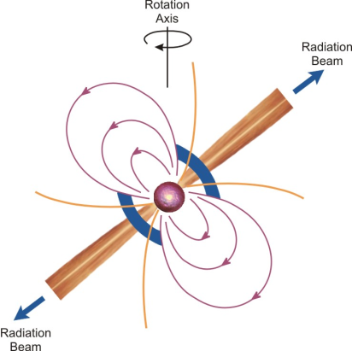
- Small, dense, rotating objects that emit radio waves
- Not visible, even with a good telescope.

Black Holes
- Extremely small, dense core of a star
- Very strong gravity, even light cannot escape (hence the name)
- As nearby material falls into the black hole it emits X-rays. We have detected X-ray sources that we believe are caused by black holes
