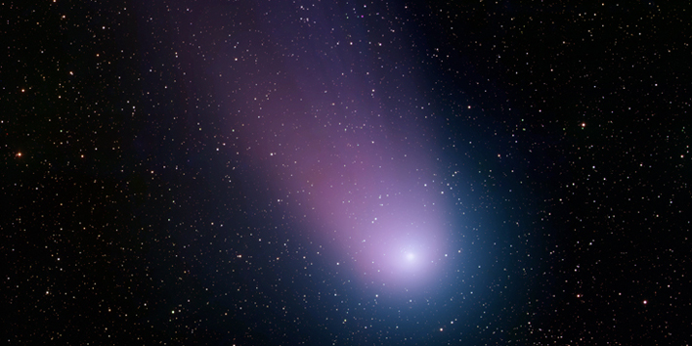
In the distant past, people were both awed and alarmed by comets, perceiving them as "long-haired" stars that appeared unpredictably and unannounced in the sky. To some ancient observers, an elongated comet looked like a fiery sword blazing across the night sky. Chinese astronomers kept extensive records for centuries, including illustrations of characteristic types of comet tails. They recorded the times of cometary appearances and disappearances in addition to celestial positions. These historic comet annals have proven to be a valuable resource for later astronomers.
We now know that comets are leftovers from the dawn of the Solar System around 4.6 billion years ago, and consist mostly of ice coated with dark organic material. They have been referred to as dirty snowballs. They may yield important clues about the formation of our solar system. Comets may have brought water and organic compounds, the building blocks of life, to the early Earth and other parts of the Solar System.
Each comet has a tiny frozen part, called a nucleus, often no bigger than a few kilometers across. The nucleus contains icy chunks and frozen gases with bits of embedded rock and dust. The nucleus may have a small rocky core.
As theorized by astronomer Gerard Kuiper in 1951, a disc-like belt of icy bodies exists just beyond Neptune, where a population of dark comets orbits the Sun in the realm of Pluto. These icy objects, occasionally pushed by gravity into orbits bringing them closer to the Sun, become the so-called short-period comets. They take less than 200 years to orbit the Sun, and in many cases their appearance is predictable because they have passed by before.
Less predictable are long-period comets, many of which arrive from a region called the Oort Cloud about 100,000 astronomical units (AU) (that is, 100,000 times the distance between Earth and the Sun) from the Sun. These Oort Cloud comets can take as long as 30 million years to complete one trip around the Sun.
Comet Borrelly as seen by Deep Space 1.

A comet warms up as it nears the Sun and develops an atmosphere, or coma. The Sun's heat causes ices on the nucleus surface to change to gases so that the coma gets larger. The coma may be hundreds of thousands of kilometers in diameter. The pressure of sunlight and high-speed solar particles (solar wind) blows the coma materials away from the Sun, forming a long, and sometimes bright, tail. Comets actually have two tails -- a dust tail and a plasma (ionized gas) tail.
Most comets travel a safe distance from the Sun -- comet Halley comes no closer than 89 million kilometers (55 million miles). However, some comets, called sun-grazers, crash straight into the Sun or get so close that they break up and evaporate.
Scientists have long wanted to study comets in some detail, tantalized by the few 1986 images of comet Halley's nucleus from the Giotto mission. NASA's Deep Space 1 spacecraft flew by comet Borrelly in 2001 and photographed its nucleus, which is about 8 kilometers (5 miles) long.
NASA's Stardust mission successfully flew within 236 kilometers (147 miles) of the nucleus of Comet Wild 2 in January 2004, collecting cometary particles and interstellar dust for a sample return to Earth in 2006. The photographs taken during this close flyby of a comet nucleus show jets of dust and a rugged, textured surface. Analysis of the Stardust samples suggests that comets may be more complex than originally thought. Minerals formed near the Sun or other stars were found in the samples, suggesting that materials from the inner regions of the Solar System traveled to the outer regions where comets formed.
Another NASA mission, called Deep Impact, consisted of a flyby spacecraft and an impactor. In July 2005, the impactor was released into the path of the nucleus of comet Tempel 1 in a planned collision, which vaporized the impactor and ejected massive amounts of fine, powdery material from beneath the comet's surface. En route to impact, the impactor camera imaged the comet in increasing detail. Two cameras and a spectrometer on the flyby spacecraft recorded the dramatic excavation that revealed the interior composition and structure of the nucleus.
The Deep Impact spacecraft and the Stardust spacecraft are healthy and have been retargeted. Deep Impact's mission, EPOXI (Extrasolar Planet Observation and Deep Impact Extended Investigation), comprises two projects: the Deep Impact Extended Investigation (DIXI) will encounter comet Hartley 2 in 2010 and the Extrasolar Planet Observation and Characterization (EPOCh) investigation will search for Earth-size planets around other stars. NASA returns to comet Tempel 1 in 2011, when the Stardust New Exploration of Tempel 1 (NExT) mission will observe changes since Deep Impact's 2005 encounter.

How Comets Get Their Names
Comet naming can be complicated. Comets are generally named for their discoverer -- either a person or a spacecraft. This International Astronomical Union guideline was developed only in the last century. For example, comet Shoemaker-Levy 9 was so named because it was the ninth short-periodic comet discovered by Eugene and Carolyn Shoemaker and David Levy. Since spacecraft are very effective at spotting comets many comets have LINEAR, SOHO or WISE in their names.

Significant Dates
- 1070-1080: The comet later designated Halley's Comet is pictured in the Bayeux Tapestry, which chronicles the Battle of Hastings of 1066.
- 1449-1450: Astronomers make one of the first known efforts to record the paths of comets across the night sky.
- 1705: Edmond Halley determines that the comets of 1531, 1607 and 1682 are the same comet and predicts its return in 1758. The comet arrives on schedule and is later named Halley's Comet.
- 1986: An international fleet of five spacecraft converges on comet Halley as it makes its regular (about every 76 years) pass through the inner solar system.
- 1994: In the first observed planetary impact by a comet, awed scientists watch as fragments of comet Shoemaker-Levy 9 smash into Jupiter's atmosphere.
- 2001: Deep Space 1 flies by and photographs comet Borrelly.
- 2004: NASA's Stardust spacecraft collects dust samples from comet Wild 2 and images the nucleus.
- 2005: The Deep Impact impactor collides with comet Tempel 1 to reveal the interior of the nucleus.
- 2006: The Stardust sample return capsule lands in Utah carrying cometary particles and interstellar dust.
- 2009: Scientists announce that the amino acid glycine, a building block of life, was collected by the Stardust spacecraft from comet Wild 2.

Follow-Up Questions

1. How are comets formed? What are they composed of?

2. Why are comets important for our Solar System and planet?

3. What is the difference between the Oort Cloud and the Kuiper belt?

4. Describe what happens as a comet gets closer to the Sun.

5. Describe NASA’s first Deep Impact mission. What was discovered as a result of this mission?

6. How are most comets named?

