Comet Diagram
Using the definitions given, label the following diagram of a comet.
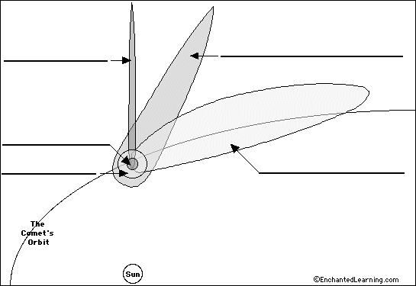
Definitions:
Coma – The roughly spherical blob of gas that surrounds the nucleus of a comet; it is about a million kilometers across. The coma is comprised of water vapor, carbon dioxide gas, and other neutral gases that have sublimed (evaporated from a solid, skipping the liquid phase) from the solid nucleus.
Dust Tail – A long wide tail buffeted by photons emitted from the Sun, but it curves slightly due to the comet’s motion.
Hydrogen Envelope – Hydrogen gas that surrounds the coma of the comet and trails along for millions of miles (it is usually between the ion tail and the dust tail). The hydrogen envelope is about 10 million kilometers across at the nucleus of the comet and about 100 million kilometers long.
Ion Tail – A tail of charged gas particles (ions) that always faces away from the sun because the solar wind (composed of ions streaming from the sun at high velocities) pushes it away.
Nucleus – The frozen center of the comet’s head. It is made of ice, gas, and dust. It contains most of the comet’s mass, but is very small (about 1 to 10 kilometers across).

Comets
- A comet’s orbit around the sun is in an ______________ shape.

- Comets usually originate from the _____________ __________ and/or the __________ _____________ (the outer reaches of our solar system).

- The dust tail and ion tail start to appear as the comet approaches the _____________. This is due to solar wind emitted from the Sun. Notice how the tail points away from the sun in the diagram below:
