Formation of the Solar System
- A rotating nebula starts to_______________. Because it rotates as it contracts, the nebula begins to flatten out.

- As the rotation and contraction continue, a bulge forms at the center (will become the _________ ). The disk of cooler material away from the centre will become the _______________.

- The cooler the matter collects into “chunks” due to________________ . Over time these “chunks” form planets.

Features of our Solar System
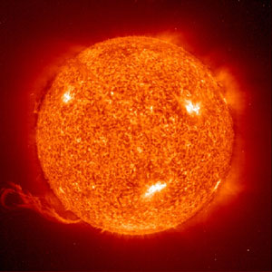
The Sun
- Formed from a _____________ about 5 billion years ago
- Currently in the _________ __________________ stage
Terrestrial Planets
- Formed from clumps of matter in the ______________ region of the nebula
- A sudden burst of energy from the Sun blasted the H (Hydrogen) and He (Helium) out of this inner region, leaving behind chunks of heavier matter
- These heavier chunks eventually collided and ________________ held them together.
- ________________, ________________, ________________,________________.
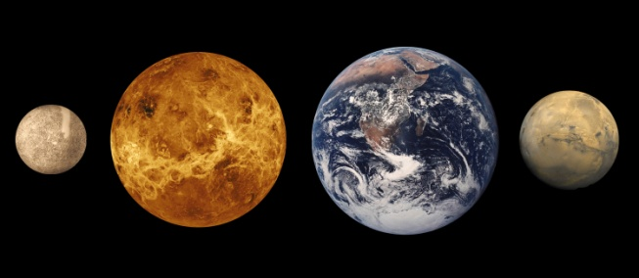

Jovian Planets
- Formed from small clumps of matter that appeared in the __________ areas of the nebula as the Sun was forming.
- These clumps condensed to form the _________ giants
- _________________, ________________, _________________, _______________
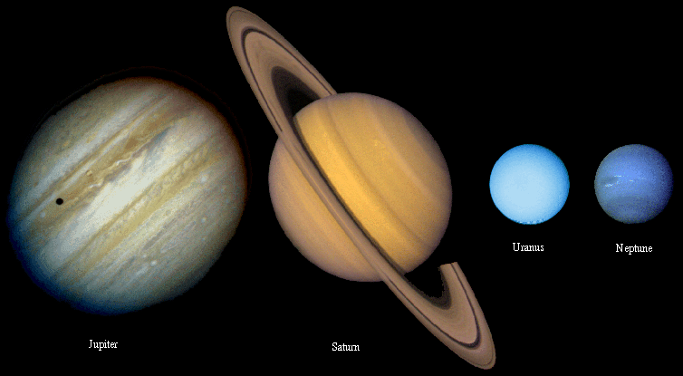

Remaining Matter
The remaining matter in the solar system eventually formed minor bodies such as_____________________, _______________, _________________ and _________________.

