Earth Science 11 - Astronomy

**Earth’s Motions**

**Revolution** - ______________ days, in a slightly elliptical orbit around the Sun.

**Rotation** – every _______________ hours, at an angle of ______________.

[**http://www.windows.ucar.edu/tour/link=/mars/mars_orbit.html**](http://www.windows.ucar.edu/tour/link=/mars/mars_orbit.html)

**Kepler’s Laws**

Johannes Kepler was a German mathematician and astronomer who came up with three laws of planetary motion:

1. First Law of Planetary Motion
2. Second Law of Planetary Motion (Equal ________ Law)
3. Third Law of Planetary Motion ( ______________ Law)



**Kepler’s Law Animation:** [**http://astro.unl.edu/classaction/animations/renaissance/kepler.html**](http://astro.unl.edu/classaction/animations/renaissance/kepler.html)

**Earth’s Seasons**

Seasons on Earth are due to the _____________ _____________. During our summer, the Sun’s rays hit the Northern Hemisphere more directly (Figure 1).

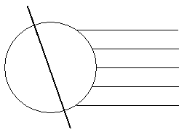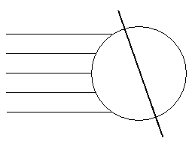

Figure 1. Summer in the Northern Hemisphere Figure 2. Summer in the Southern Hemisphere

This axis tilt and direct sunlight variation alters the seasons on Earth in two important ways:

1. Direct sunlight provides more solar radiation than indirect sunlight.
2. The portion of the Earth that is tilted towards the sun receives more hours of daylight.

**Important Events in Earth’s Annular Motions**

1. **Equinoxes** – when every location on Earth receives equal hours of daylight and nighttime (_______ hours each). On these dates neither pole is leaning towards the Sun.

Equinoxes occur twice a year:

1. Spring (Vernal) Equinox –
2. Fall (Autumnal) Equinox –

These dates mark the beginning of their respective seasons in the Northern Hemisphere.

Ex. March 21st is considered the first day of spring, and days begin to get longer towards the summer.

1. **Solstices** – Days when one pole receives no _____________ and the other no nighttime. These are the dates where the pole (either North or South) is leaning the full 23.5° towards the Sun.

Solstices occur twice a year:

1. Summer Solstice – Occurs on ______________________. The North Pole is leaning towards the Sun and the northern hemisphere experiences the longest day of the year.
2. Winter Solstice – Occurs on ____________________. The North Pole is leaning away from the Sun and the northern hemisphere experiences the shortest day of the year.

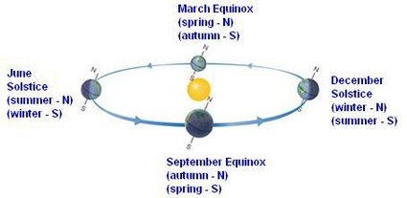The solstices mark the beginning of their respective seasons in the Northern Hemisphere. *What do you think happens on these dates in the Southern Hemisphere?*



**Follow-Up Questions (use textbook to find answers, pages 465-469)**

1. What are the shape and dimensions of Earth’s orbit?

2. What would be the effect on Earth’s seasons if:

a. The Earth’s axis was not tilted at all? Explain

b. The Earth was tilted more? Explain

3. Why are daytime and nighttime of equal length on an equinox?

4. Where is the Sun straight overhead at an equinox?

5. What are the three basic causes of Earth’s seasons?

6. What is the evidence that the distance from the sun is not a cause of seasons?