Compounds are classified in different ways: ACIDS and BASES
Confounding Colour
Predict | Observe | Explain

What is an ACID?
- Acidus (Latin word) meaning sour
- Substances which produce __________________________________ as the only POSITIVE ions when it is dissolved in water.
- Recognized in many cases as having the hydrogen at the ________________________ of the compound. [Example: HCl, HNO₃ ]
  - Acetic acid sometimes written in two ways: HCH₃COO or CH₃COOH
*Note: not all substances that contain hydrogen are acids. Example: NH₃, CH₄
Common Acids
Formula | Chemical Name | Examples of Uses
HCl(aq) |  | - Produced in stomach to help digest food
H₂SO₄(aq) |  | - Used in automobile batteries  - Used to clean metals
HNO₂(aq) |  | - Used to make fertilizers

What is a BASE?
- A base is a substance that can __________________________ from another substance
- Any METAL OXIDE or METAL HYDROXIDE
  - Example: CuO, NaOH, NH₄OH
OR
- A substance that reacts with an acid to form ________________________
  - NEUTRALIZATION REACTION
- Can recognize many bases because of: _____________
Common Bases
Formula | Chemical Name | Examples of Users
NaOH |  | - Drain and oven cleaner  - Used to manufacture paper, glass and soap
Mg(OH)₂ |  | - Active ingredient in some antacids
Ca(OH)₂ |  | - Soil and water treatment
NH₄OH |  | - Kitchen cleaner  - Used to make fertilizer

PROPERTIES OF ACIDS AND BASES
Property | Acid | Base
Taste  CAUTION: Never taste chemicals in the classroom. | - Acids taste ___________ | - Bases taste ____________
Touch  CAUTION: Never touch chemicals with your bare skin in the classroom | - Many acids will _________ your skin. | - Bases feel _____________  - Many bases will _________ your skin
Indicator Tests  pH | - Acids turn blue litmus paper ___________  - ________ than 7 | - Bases turn red litmus paper ___________  ________ than 7
Reaction with some metals, such as magnesium or zinc | - Acids _______________ metal | - ____________________
Electrical Conductivity | - __________________ | - ____________________
Production of ions | - Acids form __________________ ions when dissolved in water | - Bases form __________________ ions when dissolved in solution.
QUICK REVIEW!
How can you recognize an acid and base by their chemical formula?
What does corrosive mean?
What does BAR and BRB stand for?
pH SCALE
Many of the solutions that acids and bases form are clear liquids and look like water. However, they could be quite dangerous depending on their pH level. A safe way to determine whether a solution is acidic or basic, is to use a _____ .
pH indicators are ___________________ that change from one ___________________ to another colour depending on the pH level of the solution that they are placed in. Each indicator changes at a specific pH.
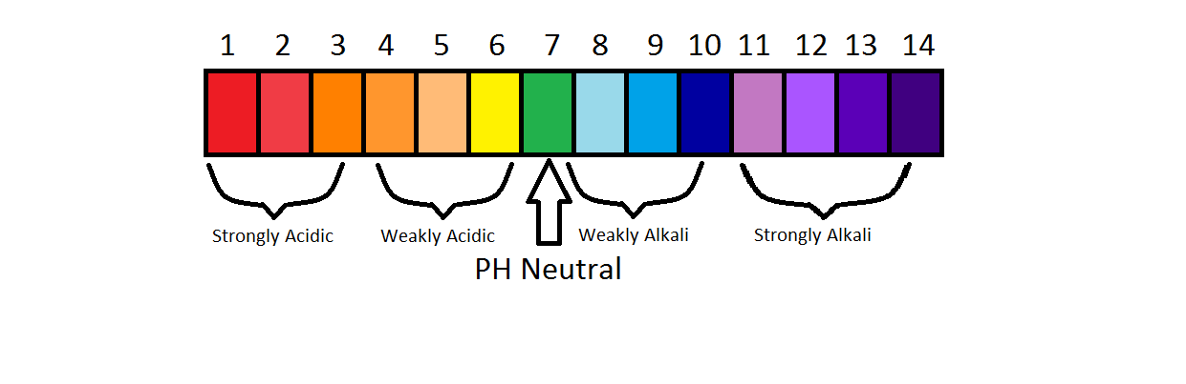
Universal indicator changes a variety of colours depending on the pH
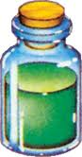
Investigation into some Common Household Products

Your task:
- Choose 6 common household products and write their names in the first column below
- Place a paper towel under your spot plate and label next to 6 “spots” the names of your products above
- Place 3 or 4 drops of each household product in the labeled spot on your spot plate.
- In the second column, predict whether each of the household items is an acid or a base and briefly explain why you think this.
- Add 1-2 drops of universal indicator to each “spot” and write down the colour it turns
- Check the pH scale at the front of the room to see your results and write down the pH in the next column and indicate if it actually is an acid or a base.

Household Product | Prediction  (Acid or Base? Why?) | Universal Indicator Colour | pH | Acid or Base  (final answer)

USING THE PH SCALE

- We know, for example: A solution of pH 3 is MORE acidic and contains HIGHER [H⁺] than a solution of pH 6 for the same concentration of both solutions
- How do we know how many times more acidic?

EXAMPLE:

PRODUCTION OF IONS
- Acids produce H⁺ when dissolved in solution; Bases produce OH⁻
- Testing pH measures H⁺_{(aq)} concentration
- [H⁺] refers to the number of hydrogen ions in a specific volume of solution
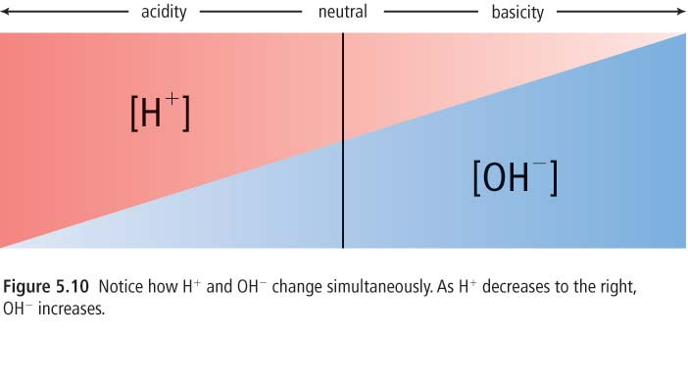
- When separate solutions containing H⁺ and OH⁻ ions are combined, they react by forming water: H⁺ + OH⁻ H₂O
QUICK REVIEW!
How does litmus paper work?

On the ph scale: What numbers are acidic? Basic? Neutral?

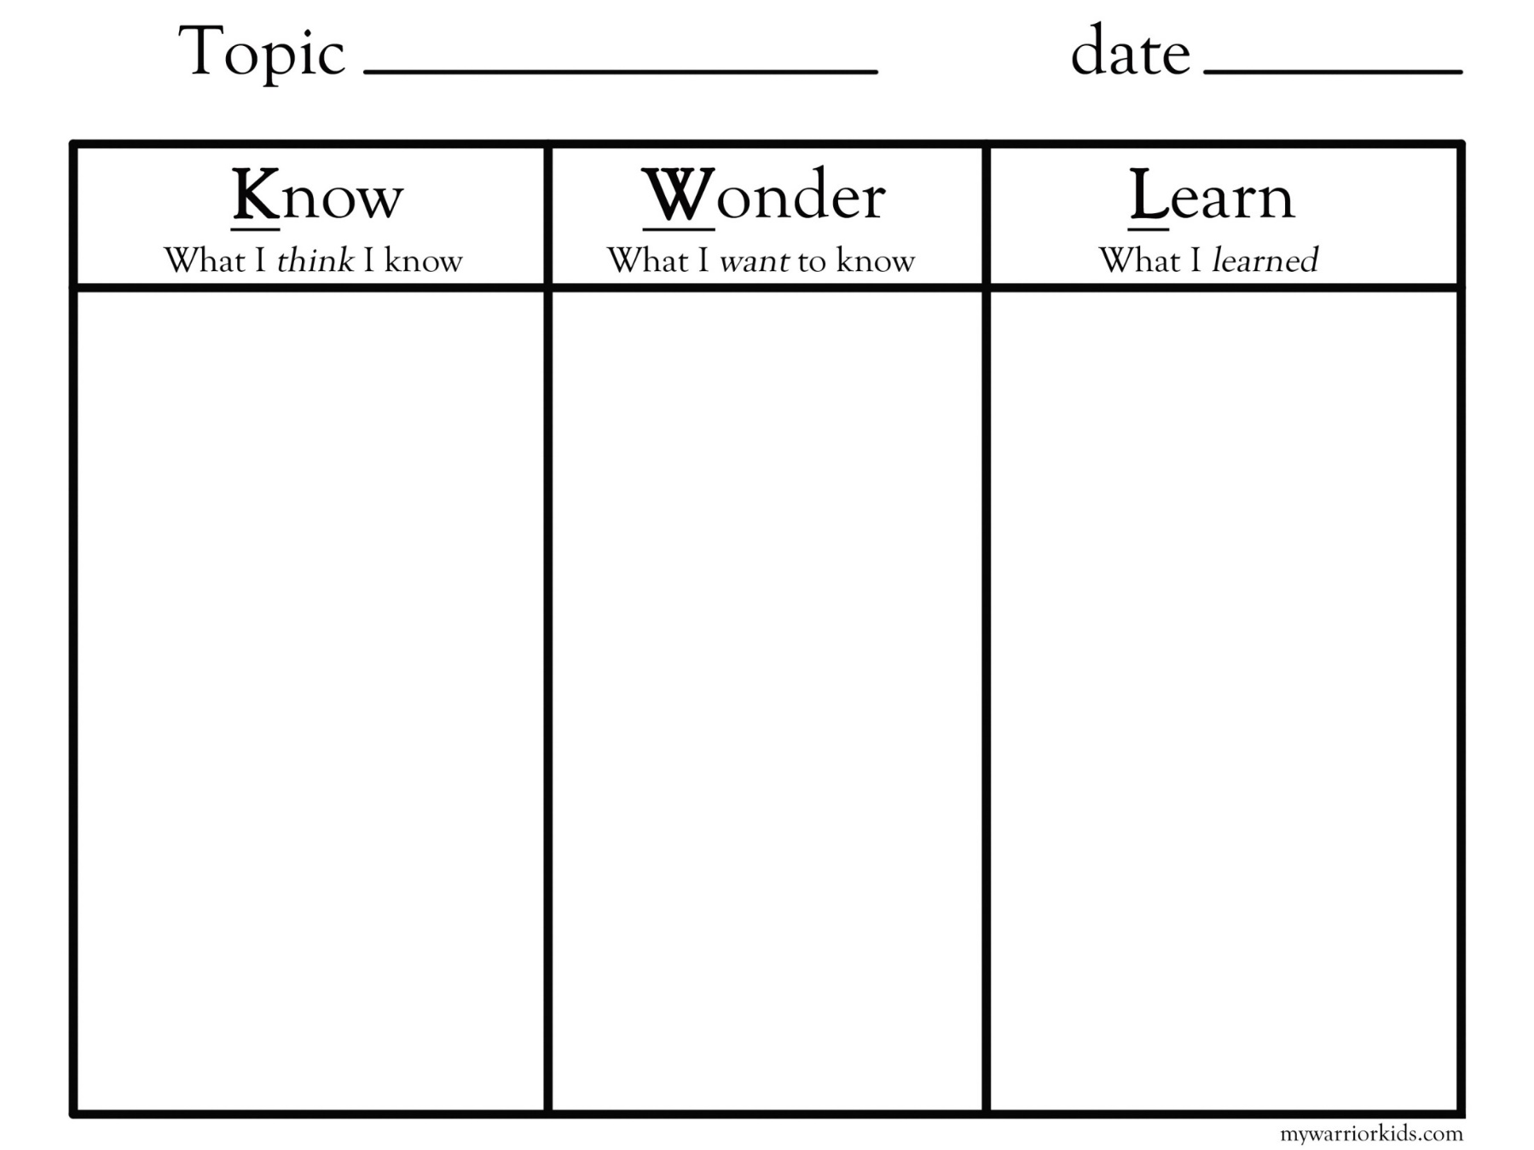
How many times more acidic is ph 2 than ph 8?

