Recall: Indicators:
Name: Date:
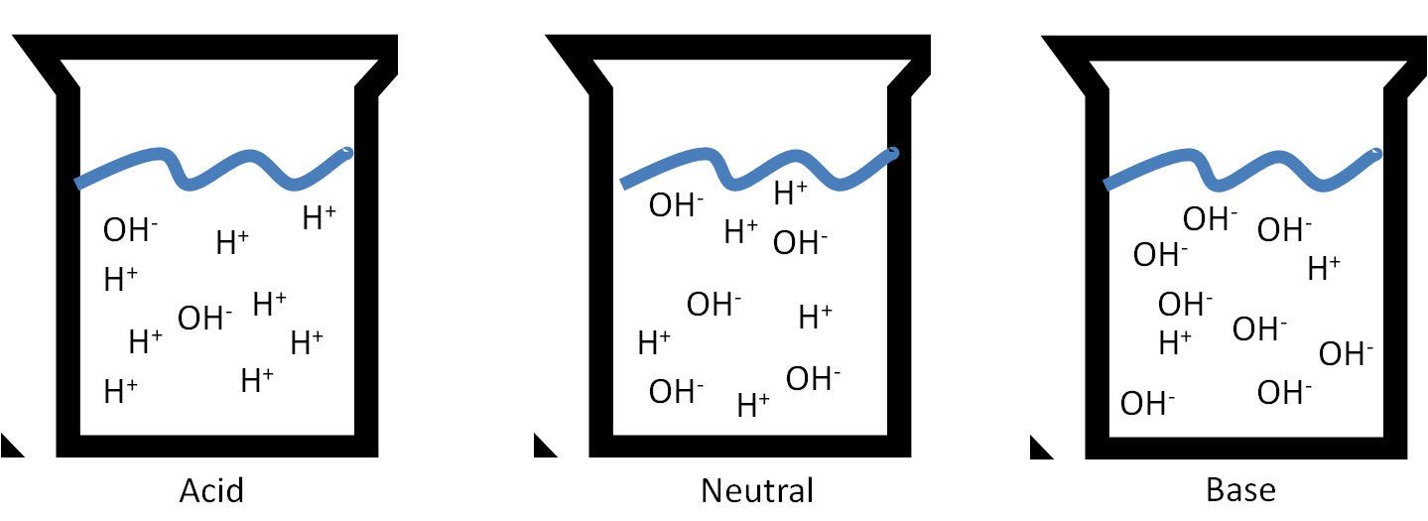
- There are common acids and bases that form colorless solutions; water-like solutions that can be very dangerous.
- Recall:
- pH indicators: chemicals that change color depending on the pH of the solution they are placed in

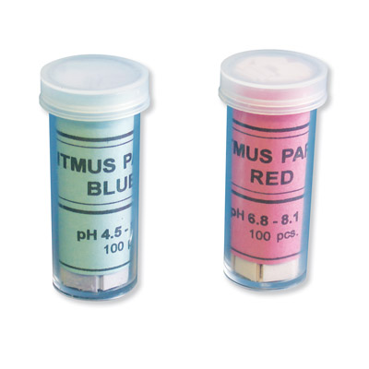
Using Litmus Paper:
- in neutral solutions, blue litmus stays blue and red litmus stays red
  - ie. Litmus does change at pH 7
- BAR:
- BRB:
Indicators:
- Universal Indicator
  - contains a number of indicators that turn different colors depending on the pH of the solution
- Digital pH meters or pH computer probe measure an electrical property of the solution and uses this to determine the pH
Other pH Indicators:
- Litmus paper is effective in telling us whether something is neutral, basic (7<pH<14), or acidic (1<pH<7).
- BUT:

- Ex. Phenolphthalein is colourless in acidic or slightly basic solutions but turns pink in moderately to highly basic solutions

Acid-Base Indicators
Acid-base indicator | pH Range in Which Colour Change Occurs | Colour Change as pH Increases
Methyl orange | 3.2-4.4 | Red to yellow
Methyl red | 4.8-6.0 | Red to yellow
Bromothymol Blue | 6.0-7.6 | Yellow to blue
Litmus | 7.0 | Red to blue
Phenolphthalein | 8.2-10.0 | Colourless to pink
Indigo carmine | 11.2-13.0 | Blue to yellow
