SALTS

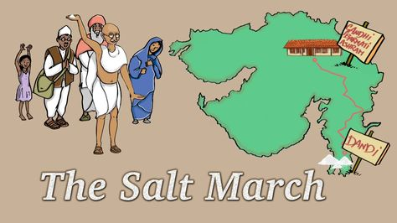
Salt History
- Ghandi led a 400km march of thousands of Indians to the ocean to gather salt from the beach in protest of the tax on salt required by the ruling British.
- Civilizations around the world have placed a great value on table salt because it is so necessary to life!
  - At various times throughout human history, table salt was worth its weight in gold, wages were paid in salt, and wars were fought over the salt trade.

- Common table salt is chemically sodium chloride and is normally obtained from seawater, salt lakes, or rock deposits.
- Both sodium and chlorine are chemical elements that are necessary for our survival

How are Salts connected with Acids and Bases?
- Sodium chloride is only one of many types of salts, all of which can trace their origin to acids and bases
- _____________________________________________________________

_____________________________________________________________

- In chemistry, ____________________________________________ that
can be formed during:

_______________________________________________________.

Importance
- Different kinds of salts are used in a variety of ways, such as:
  - Making of batteries
  - Explosives
  - Fertilizers
  - Multivitamins
  - In many living cells
    - Cytoplasm in cells
    - Sap in plants
    - Blood and urine in animals

Acid-Base Neutralization
- Neutralization: the name for the type of chemical reaction that occurs when:

_____________________________________________________________

- Example: HCl + NaOH NaCl + H₂O
  - Acid + base salt + water

  - In this reaction, the salt produced is sodium chloride, or table salt.

Example

- 3H₂SO₄ + 2 Al(OH)₃ Al₂(SO₄)₃ + 6H₂O
ACID + BASE SALT + WATER

- Aluminum Sulfate is used to reduce pH of garden soil and used in water purification because it helps impurities stick together and settle out.

- Aluminum sulfate is prepared by dissolving sodium hydroxide in sulfuric acid.

Quick Review
- Practice Problems: Complete the reaction (Hint*: make sure it is also balanced!)

- HCl + KOH

- H₂CO₃ + Mg(OH)₂

- HNO₃ + Ca(OH)₂

Metal Oxides and Non-Metal Oxides
- Metals react with oxygen to form oxides
- Oxide: chemical compound that includes at least 1 oxygen atom or ion along with 1 or more other elements

- Metal Oxide: chemical compound that contains a
_____________________________________________________________
- When a metal oxide dissolves in water, _____________________________

Na₂O_{(s)} + H₂O_{(l)} 2NaOH_{(aq)} [sodium hydroxide a base]

- Non-metals also react with oxygen to form oxides, such as carbon dioxide and sulfur dioxide

- Non-Metal Oxide: chemical compound that contains a

_____________________________________________________________

- When non-metal oxides dissolve in water, ___________________________

SO_{2(g)} + H₂O_{(l)} H₂SO_{3(aq)}
2NO_{2(g)} + H₂O_{(l)} HNO_{2(aq)} + HNO_{3(g)}
Human Impacts
- When fuels such as coal and gasoline are burned, they combine with oxygen.
  - The products are non-metal oxides which are released into the atmosphere
  - The non-metal oxides dissolve in rainwater to produce acid precipitation (rain)

Environmental Concerns
- Acid precipitation gets into freshwater ecosystems and harms plants and farm crops
- It also reacts chemically to damage limestone in buildings and monuments
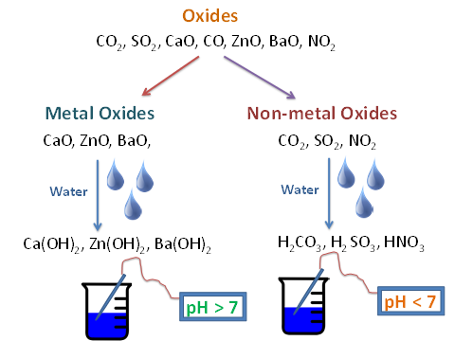

Recall:
- Periodic table organizes elements based on similar chemical properties

Quick Review
- What 2 types of pure substances are produced from the neutralization of an acid and a base?

- What environmental problem is associated with the burning of coal and gasoline?

- When a non-metal oxide is mixed with water, does the water become acidic or basic?
  - A metal oxide?

